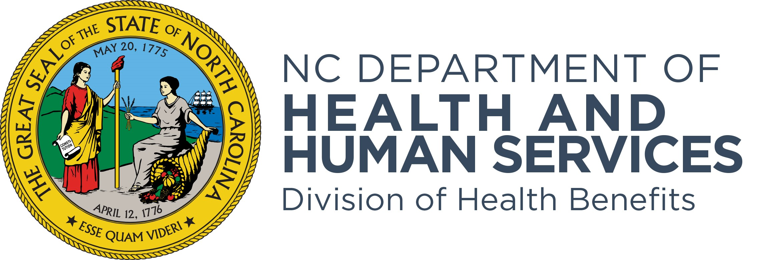
Stakeholder Engagement
Behavioral Health Clinical Coverage Policy Updates

NC Medicaid is offering a second opportunity to join the virtual office hours for the 1115 Substance Use Disorder Demonstration Waiver clinical coverage policies included below. Health Plans and providers are encouraged to submit questions in advance for discussion during virtual office hours. These webinars are open to all stakeholders.
Webinar Dates & Times | MS Teams Links
Wednesday, Oct. 15, 2025, 2:30 p.m. – 3:00 a.m.  8A-12 Substance Abuse Intensive Outpatient Program  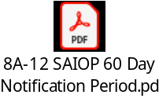 | Join on your computer, mobile app or room device  Click here to join the meeting  Meeting ID: 216 761 388 536 5  Passcode: Tx6kP7rv  Dial in by phone  +1 984-204-1487,,227281164# United States, Raleigh  Find a local number  Phone conference ID: 227 281 164#  Join on a video conferencing device  Tenant key: ncgov@m.webex.com  Video ID: 115 747 246 6  More info
Monday, Oct. 20, 2025, 10:00 a.m. – 10:30 a.m.  8A-13 Substance Abuse Comprehensive Outpatient Treatment  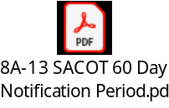 | Join on your computer, mobile app or room device  Click here to join the meeting  Meeting ID: 269 951 292 333 2  Passcode: zJ9qA6aQ  Dial in by phone  +1 984-204-1487,,888343370# United States, Raleigh  Find a local number  Phone conference ID: 888 343 370#  Join on a video conferencing device  Tenant key: ncgov@m.webex.com  Video ID: 113 407 336 0  More info
Tuesday, Oct. 21, 2025, 9:15 a.m. – 9:45 a.m.  8A-10 Clinically Managed Residential Withdrawal Management Service  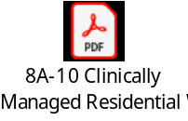 | Join on your computer, mobile app or room device  Click here to join the meeting  Meeting ID: 289 371 601 443 2  Passcode: zw95vk94  Dial in by phone  +1 984-204-1487,,268941593# United States, Raleigh  Find a local number  Phone conference ID: 268 941 593#  Join on a video conferencing device  Tenant key: ncgov@m.webex.com  Video ID: 118 974 644 4  More info
Thursday, Oct. 23, 2025, 2:45 p.m. – 3:15p.m.  8D-3 Clinically Managed Low-Intensity Residential Treatment Services  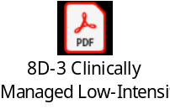 | Join on your computer, mobile app or room device  Click here to join the meeting  Meeting ID: 251 375 388 614 1  Passcode: 8AD3wt6H  Dial in by phone  +1 984-204-1487,,895250238# United States, Raleigh  Find a local number  Phone conference ID: 895 250 238#  Join on a video conferencing device  Tenant key: ncgov@m.webex.com  Video ID: 112 545 867 4  More info
Friday, Oct. 24, 2025, 8:30 a.m. – 9:00 a.m.  8D-4 Clinically Managed Population Specific High-Intensity Residential Program  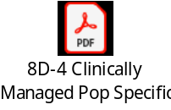 | Join on your computer, mobile app or room device  Click here to join the meeting  Meeting ID: 234 594 153 273 9  Passcode: K4iG9gC2  Dial in by phone  +1 984-204-1487,,64260145# United States, Raleigh  Find a local number  Phone conference ID: 642 601 45#  Join on a video conferencing device  Tenant key: ncgov@m.webex.com  Video ID: 118 864 936 2  More info
Monday, Oct. 27, 2025, 8:30 a.m. – 9:00 a.m.  8D-5 Clinically Managed Residential Services  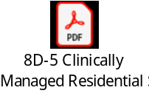 | Join on your computer, mobile app or room device  Click here to join the meeting  Meeting ID: 244 147 684 210 5  Passcode: jP67eX2f  Dial in by phone  +1 984-204-1487,,390264366# United States, Raleigh  Find a local number  Phone conference ID: 390 264 366#  Join on a video conferencing device  Tenant key: ncgov@m.webex.com  Video ID: 118 836 375 7  More info
Monday, Oct. 27, 2025, 11:30 a.m. – noon  8D-6 Medically Monitored Intensive Inpatient Services  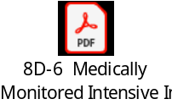 | Join on your computer, mobile app or room device  Click here to join the meeting  Meeting ID: 254 594 564 618 8  Passcode: qd6E3Y6h  Dial in by phone  +1 984-204-1487,,484646523# United States, Raleigh  Find a local number  Phone conference ID: 484 646 523#  Join on a video conferencing device  Tenant key: ncgov@m.webex.com  Video ID: 119 976 266 9  More info

Please email questions in advance for discussion during Virtual Office Hours to eboni.burton@dhhs.nc.gov.

