E-CONTRACTS – Signing Contracts Electronically

Partners BHM uses DocuSign, an online e-contracting service that will allow you to sign contracts electronically. The contract arrives by secure email, you follow the link to a secure online website, review and sign the contract, download a copy if you would like, and you are done. Completed confirmations come to you also by email.

Partners will require contracts be signed through the electronic process. DocuSign offers free technical support. See, e.g., the attached DocuSign guide.

LEGALITY: E-contracts are valid like any other intentionally signed document.

E-contracts are legal. Not only are electronic signatures and contracts endorsed and encouraged by the State of North Carolina, but they are supported by two state and one federal sets of laws, in place for a decade or so:
- Electronic Commerce Act (ECA), N.C. Gen. Stat. § 66-58.1, et seq.: Encourages electronic transactions with public agencies.
  - “All public agencies may use and accept electronic signatures pursuant to this Article, pursuant to Article 40 of this Chapter (the Uniform Electronic Transactions Act), or pursuant to other law.” N.C. Gen. Stat. § 66-58.4.
  - “An electronic signature contained in a transaction undertaken pursuant to this Article between a person and a public agency, or between public agencies, shall have the same force and effect as a manual signature [if meets listed criteria] … A transaction undertaken pursuant to this Article between a person and a public agency, or between public agencies, is not unenforceable, nor is it inadmissible into evidence, on the sole ground that the transaction is evidenced by an electronic record or that it has been signed with an electronic signature.” N.C. Gen. Stat. § 66-58.5(a) and (b).”

- Uniform Electronic Transactions Act (UETA), N.C. Gen. Stat. § 66-311, et seq.: A law adopted in 47 states and the U.S. Virgin Islands:
“(a) A record or signature may not be denied legal effect or enforceability solely because it is in electronic form.
(b) A contract may not be denied legal effect or enforceability solely because an electronic record was used in its formation.
(c) If a law requires a record to be in writing, an electronic record satisfies the law provided it complies with the provisions of this Article.
(d) If a law requires a signature, an electronic signature satisfies the law provided it complies with the provisions of this Article.”
- Electronic Signatures in Global and National Commerce Act (ESIGN), 15 U.S.C. § 7001, et seq.
These laws provide that electronic records and signatures carry the same weight and legal effect as traditional paper documents and handwritten signatures. In fact, these laws retain the same rule of intent for e-signatures as handwritten signatures: a signature is only valid if the signer intends to sign. DocuSign is designed so you cannot “accidentally” sign an agreement, and provides a certificate tracking its routing and signature. These contracts satisfy courts and auditors.

HOW DOCUSIGN WORKS

When someone sends you a DocuSign document for your electronic signature, you first receive an email from DocuSign sent on behalf of the sender.
DocuSign recently released a New Signing Experience for customers. Your experience as a signer may vary depending on which signing experience the sender is using.
Click the image that looks most like the signing email you received: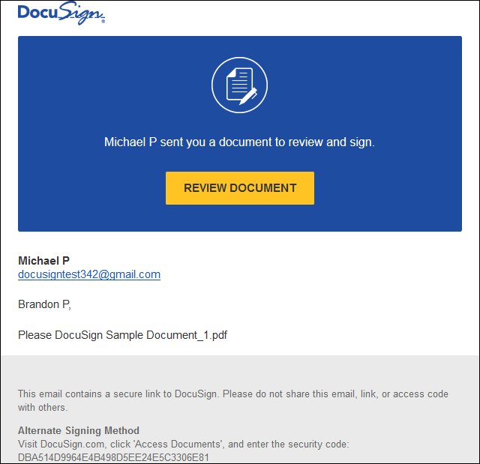

New Signing Experience

Step 1 Review the DocuSign email
Open the email and review the message from the sender. Click REVIEW DOCUMENT to begin the signing process.
Note: Your experience as a signer may also vary depending on how the document sender wants you to sign. New signers have a different experience than returning signers and signers with a DocuSign account. To learn more, watch the Signing video or read the how-to guide Signing Documents Electronically with DocuSign.

Step 2 Agree to sign electronically
Review the consumer disclosure, and select the checkbox I agree to use Electronic Records and Signatures. Click CONTINUE to begin the signing process.
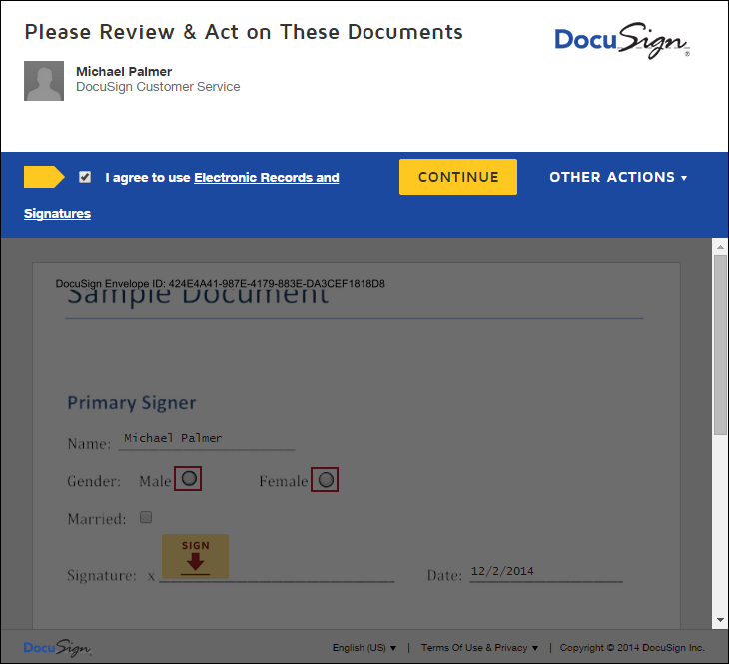
Important! To view and sign the documents, you must agree to conduct business electronically.
Note: To view additional options, click OTHER ACTIONS. For more information of other actions available, please review our Signing Documentation.

Step 3 Start the signing process
- Click the START tag on the left to begin the signing process.
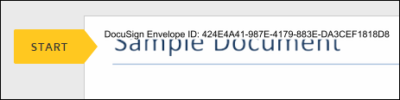
You are taken to the first tag requiring your action.

- Click the SIGN tag. You are asked to Adopt Your Signature.
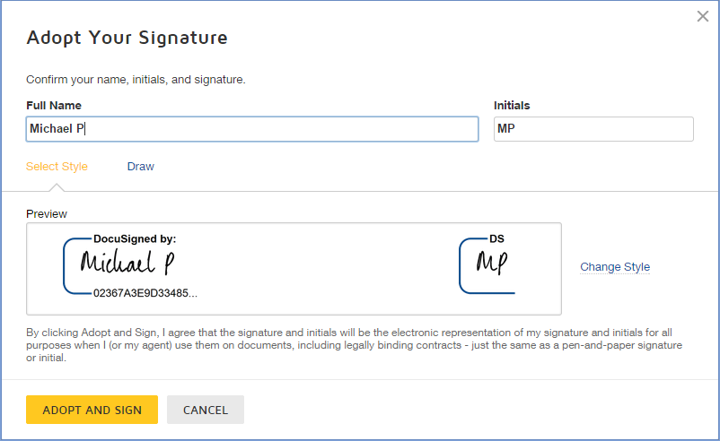

Step 4 Verify your name
Verify that your name and initials are correct. If not, change them as needed.

Step 5 Adopt a signature
Do one of the following:
- Accept the default signature and initial style, and go to the next step.
- Click Change Style, and select a different signature option.
- Click Draw. Draw your signature/initials using a mouse, or your finger or a stylus on a touchscreen.
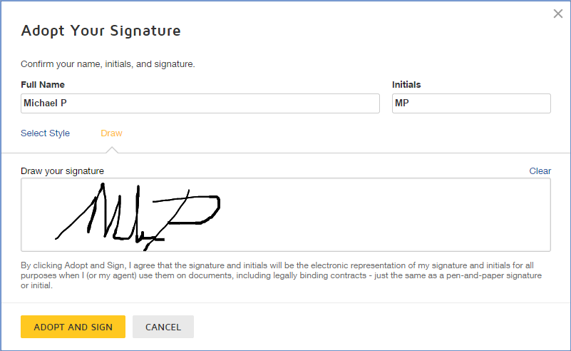

Step 6 Save your signature
Click ADOPT AND SIGN to adopt and save your signature information and return to the document.

Step 7 Confirm signing
When you finish clicking all signature tags in the document, confirm signing by clicking FINISH. 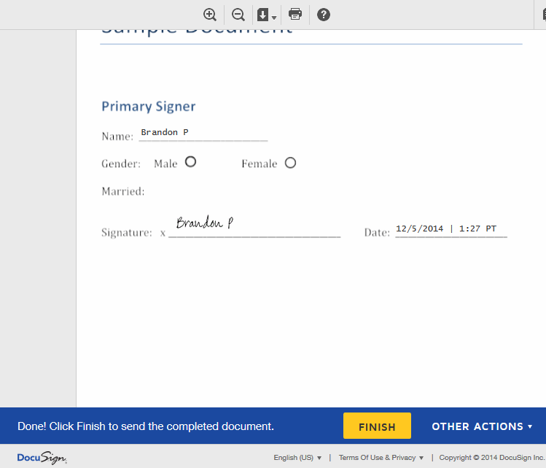
A message appears stating that you have completed your document. You can now download a PDF copy or print a copy of the document. The sender receives an email with the signed document attached, and the signed document appears in their DocuSign account.

Step 8 Sign up for a DocuSign account
Sign up for a DocuSign account and save the document in your own account.
Previous Signing Experience

Step 1 Review the DocuSign email
Open the email and review the message from the sender. Click Review Documents to begin the signing process.
Note: Your experience as a signer may also vary depending on how the document sender wants you to sign. New signers have a different experience than returning signers and signers with a DocuSign account. To learn more, watch the Signing video or read the how-to guide Signing Documents Electronically with DocuSign.
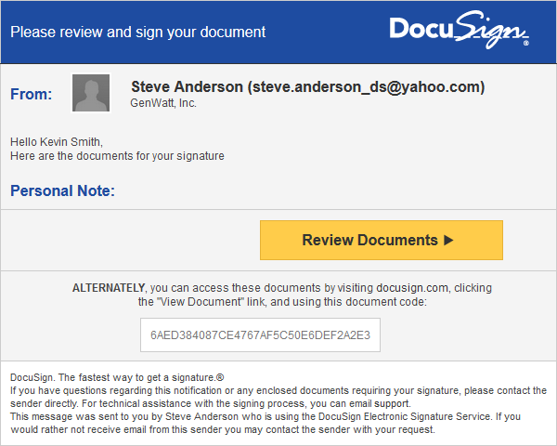

Step 2 Agree to sign electronically
Review the consumer disclosure, and select the checkbox I agree to do business electronically with [sender name]. Click Review Documents to continue. The first page of the document opens.
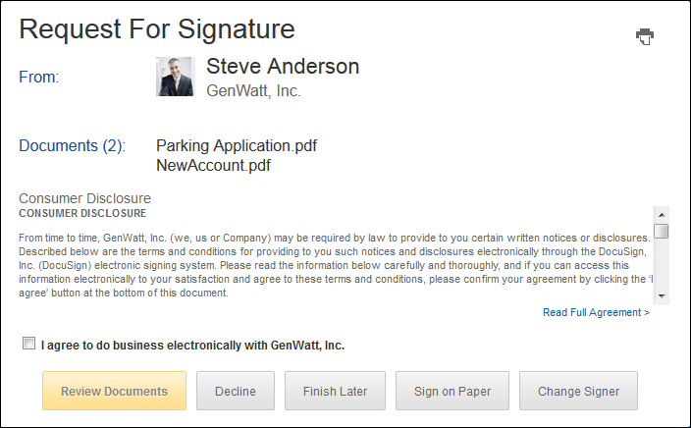
Important! To view and sign the documents, you must agree to conduct business electronically.

Step 3 Start the signing process
- Click the Start tag on the left to begin the signing process.
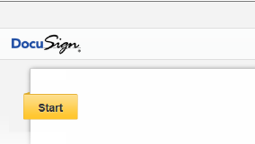
You are taken to the first tag requiring your action.

- Click the Sign Here tag. You are asked to Adopt Your Signature.
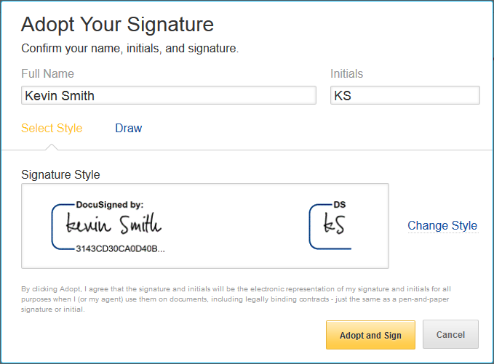

Step 4 Verify your name
Verify that your name and initials are correct. If not, change them as needed.

Step 5 Adopt a signature
Do one of the following:
- Accept the default signature and initial style, and go to the next step.
- Click Change Style, and select a different signature option.
- Click Draw. Draw your signature/initials using a mouse, or your finger or a stylus on a touchscreen.
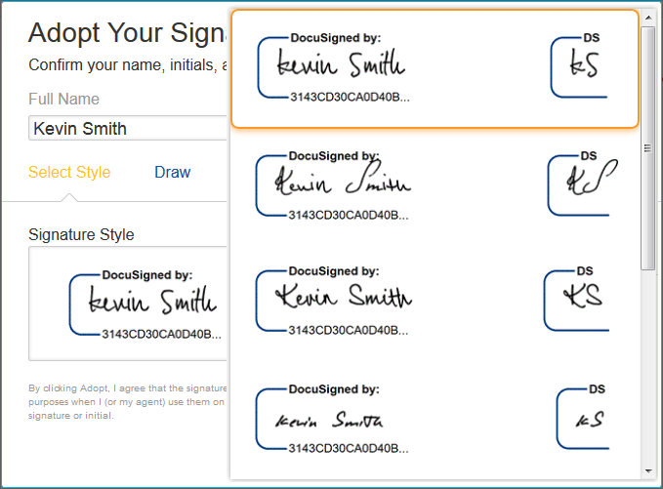

Step 6 Save your signature
Click Adopt and Sign to adopt and save your signature information and return to the document.

Step 7 Confirm signing
When you finish clicking all signature tags in the document, the Confirm Signing tag appears. Click Confirm Signing.
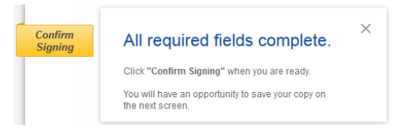
A message appears stating that you have completed your document. You can now download a PDF copy or print a copy of the document. The sender receives an email with the signed document attached, and the signed document appears in their DocuSign account.

Step 8 Sign up for a DocuSign account
Sign up for a DocuSign account and save the document in your own account.

